**CHAPTER ONE: INTRODUCTION**

### 1.1 BACKGROUND OF THE STUDY

Employee management systems (EMS) are crucial for modern organizations to streamline their human resource processes. These systems facilitate the efficient handling of employee data, recruitment processes, performance tracking, and internal communications. The advent of digital solutions in HR management has significantly reduced the administrative burden, allowing HR professionals to focus on strategic initiatives. Your proposed EMS aims to enhance these capabilities by providing a comprehensive platform for managing employee applications, interviews, and internal communications. By integrating features such as resume submission, interview scheduling, and template management for various HR letters, your system addresses the need for a centralized and efficient HR management tool.

### 1.2 STATEMENT OF THE PROBLEM

Traditional methods of managing employee data and recruitment processes are often cumbersome and prone to errors. Manual handling of resumes, interview scheduling, and communication can lead to inefficiencies and delays. There is a need for a robust system that can automate these processes, ensuring accuracy and saving time for HR professionals.

### 1.3 AIM AND OBJECTIVES

The aim of this project is to develop an Employee Management System that automates and streamlines HR processes. The objectives include:

1. Enabling prospective employees to submit resumes online.
2. Allowing admins to review, accept, or reject applications.
3. Facilitating interview scheduling and management.
4. Providing a repository for various HR letter templates.
5. Managing staff permissions for leaves, late arrivals, and exits.
6. Enhancing internal communication through an integrated mailing system.

### 1.4 SCOPE AND DELIMITATION

The scope of this project includes the development of a web-based application that supports the aforementioned functionalities. The system will be designed for use by HR managers, admins, and heads of departments (HODs). Delimitations include focusing on core HR functionalities and excluding advanced features such as payroll management and performance analytics.

### 1.5 DEFINITION OF TERMS

* **Employee Management System (EMS)**: A software application designed to manage various HR processes including recruitment, employee data management, and internal communications.
* **Admin**: A user with the highest level of control over the system, responsible for managing applications and overseeing HR processes.
* **HOD (Head of Department)**: A user responsible for managing staff within a specific department, including approving leaves and viewing staff details.
* **Internal Mailing System**: A feature within the EMS that allows users to communicate seamlessly within the organization.

**CHAPTER TWO: LITERATURE REVIEW**

**2.1 INTRODUCTION**

Sheep. Yes, sheep. When you think of a herd of sheep, what do you envision? You may view docility, humility or things if that sort. I, however I see lack of a structured system, a follow the leader blindly kind of situation. This methodology, for a highly nuanced entity like the human, is nothing short of asinine. Still in all, why contrary to the human’s brain do we need structures that are facile? This is because like our anatomy, we have a way of making complex our thinking. This base is why I find Opibus to be very auspicious.

In today’s fast-paced corporate world, efficient management of human resources is paramount to an organization’s success. Opibus is designed to revolutionize the way companies handle their HR processes. Imagine a seamless platform where prospective employees can effortlessly submit their resumes, and HR managers can swiftly review and manage applications. This system empowers administrators to schedule interviews, manage staff permissions, and store essential HR templates, all in one place. With an integrated internal mailing system, communication within the organization becomes more streamlined than ever. The EMS not only enhances productivity but also ensures that every HR task is executed with precision and ease. By automating routine tasks and providing a centralized hub for all HR activities, Opibus is set to transform the HR landscape, making it more efficient, transparent, and responsive to the needs of both employees and management. Welcome to the future of employee management!

**2.2 THEORY**

The implementation of an Employee Management System (EMS) is grounded in the principles of organizational efficiency and data-driven decision-making. At its core, an EMS leverages technology to streamline HR processes, reduce administrative burdens, and enhance overall productivity. The theory behind such systems is rooted in the concept of digital transformation, where traditional manual processes are replaced by automated, integrated solutions. This transformation not only improves accuracy and efficiency but also provides valuable insights through data analytics. By centralizing employee data, an EMS enables better workforce planning, performance tracking, and compliance management. The system’s ability to facilitate seamless communication and document management further supports the theory that a well-implemented EMS can lead to a more engaged and motivated workforce. In essence, the adoption of an EMS is a strategic move towards creating a more agile, responsive, and data-informed HR function, ultimately contributing to the organization’s competitive advantage in the marketplace.

**CHAPTER THREE: SYSTEM ANALYSIS AND DESIGN**

**3.1 ANALYSIS OF THE EXISTING SYSTEM**

Current Employee Management Systems (EMS) have significantly evolved, offering comprehensive solutions for HR processes such as recruitment, attendance tracking, and performance management. Systems like BambooHR and Rippling are widely recognized for their user-friendly interfaces and robust functionalities. These systems centralize employee data, automate routine tasks, and provide valuable insights through analytics. However, despite these advancements, many organizations still face challenges with integration, data security, and user adoption. The existing systems often require substantial customization to meet specific organizational needs, which can be both time-consuming and costly. Additionally, the reliance on multiple disparate systems can lead to data fragmentation and inefficiencies.

**3.2 WEAKNESS OF THE EXISTING SYSTEM**

Despite their benefits, existing EMS solutions have notable weaknesses. One major issue is the high cost of implementation and maintenance, which can be prohibitive for small and medium-sized enterprises. Additionally, these systems often suffer from integration challenges, particularly when interfacing with legacy systems or other third-party applications. Data security is another critical concern, as centralized databases can become prime targets for cyberattacks. Furthermore, user adoption can be hindered by complex interfaces and inadequate training, leading to underutilization of the system’s capabilities. Lastly, the rigidity of some systems can limit their adaptability to unique organizational processes and workflows.

**3.3 DATA COLLECTION TECHNIQUES**

During the development of this Employee Management System (EMS), I employed several research methods to gather the necessary information and insights**.**

Some of them are;

**Online Research**: Searching for existing EMS solutions, reading articles, blogs, and forums to understand the features, functionalities, and common challenges associated with such systems. Using websites like Stack Overflow, GitHub, and Medium as they are valuable resources for technical guidance and community support.

**Reviewing Documentation and Tutorials**: Accessing documentation and tutorials for popular EMS platforms like BambooHR, Rippling, or open-source alternatives would provide practical insights into system architecture, design patterns, and implementation strategies. Platforms like YouTube and Udemy for video tutorials that proved to be particularly helpful.

**Consulting with HR Professionals**: I engaged with HR professionals, gathering valuable insights into the specific needs and pain points of handling employees.

**3.4 ANALYSIS OF THE PROPOSED SYSTEM**

The proposed Employee Management System aims to address the shortcomings of existing solutions by offering a more flexible, secure, and user-friendly platform. This system will streamline HR processes by integrating resume submission, interview scheduling, and internal communications into a single, cohesive platform. By leveraging modern security protocols, the system will ensure the protection of sensitive employee data. Additionally, the proposed EMS will feature customizable modules to accommodate the unique needs of different organizations, enhancing its adaptability and user adoption. The inclusion of an internal mailing system will facilitate seamless communication, further improving organizational efficiency. Overall, the proposed system is designed to be a comprehensive, cost-effective solution that enhances HR operations and supports strategic decision-making.

**3.5 SYSTEM ALGORITHM**

1. **Initialize System**

- Connect to the MySQL database using PHP.

- Load necessary libraries and modules (e.g., Bootstrap, jQuery, CKEditor).

**2. User Authentication**

- Display login form.

- Validate user credentials against the database.

- Redirect users based on their roles (Admin, HR Manager, HOD, Employee).

**3. Resume Submission (Public Landing Page)**

- Display resume submission form using HTML and Bootstrap.

- Validate form inputs using JavaScript.

- Save resume data to the database using PHP.

**4. Application Review (Admin)**

- Fetch new applications from the database.

- Display applications for review in a table format.

- Admin can accept or reject applications.

- Update application status in the database.

**5. Interview Scheduling**

- Admin selects staff for the interview.

- Schedule interview and notify the applicant via internal mailing system.

- Save interview details to the database.

**6. Post-Interview Decision**

- Fetch interview results from the database.

- Admin approves or disapproves applicants.

- Update applicant status in the database.

**7. HR Letter Management**

- Admin/HR Manager can create, edit, and store letter templates.

- Fetch and display templates as needed.

- Save templates to the database.

**8. Staff Management**

- HOD can view, edit, and manage staff details.

- Handle leave requests, late arrivals, and exits.

- Update staff records in the database.

1. **Department Management**

- HOD can manage department-specific details.

- View and control staff within the department.

- Store, edit, and view staff details.

1. **Admin Requests Review**

- Admin can review requests for leave, late arrivals, and temporary exits.

- Approve or reject requests.

- Update request status in the database.

**11. Internal Mailing System**

- Enable internal communication between users.

- Send and receive messages using PHP and MySQL.

- Store messages in the database.

**12. Logout**

- End user session.

- Redirect to the login page.

- Disconnect from the database.

**3.6 SYSTEM FLOWCHART  
  
 1. Initialize System / User Authentication**

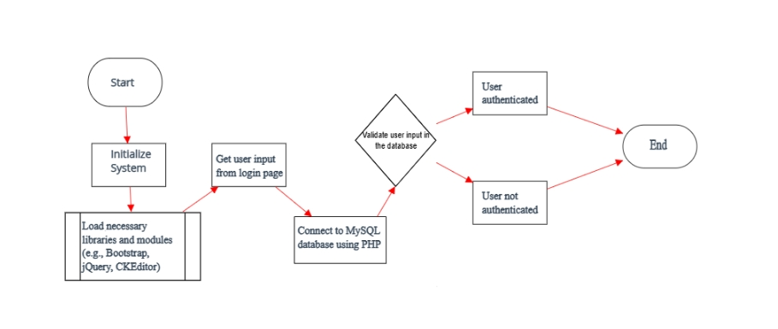

1. **Resume Submission (Public Landing Page)**

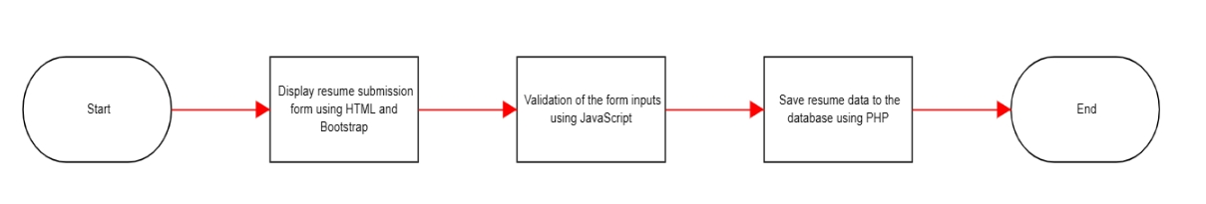

1. **Application Review (Admin)**

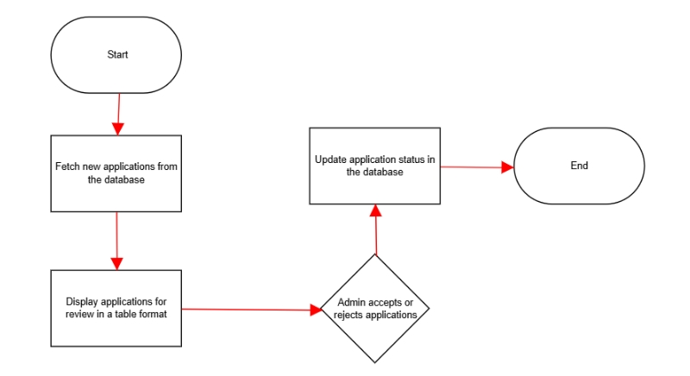

**4. Interview Scheduling**

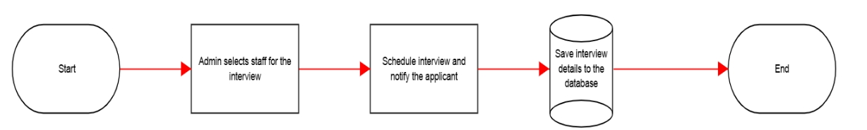

**5. Post-Interview Decision**

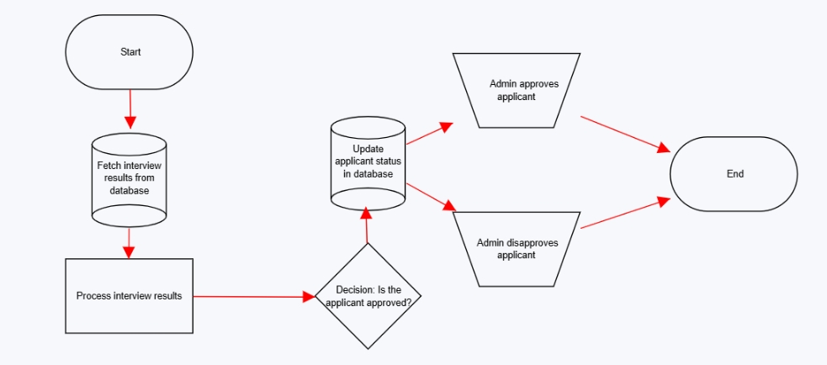

**6. HR Letter Management**

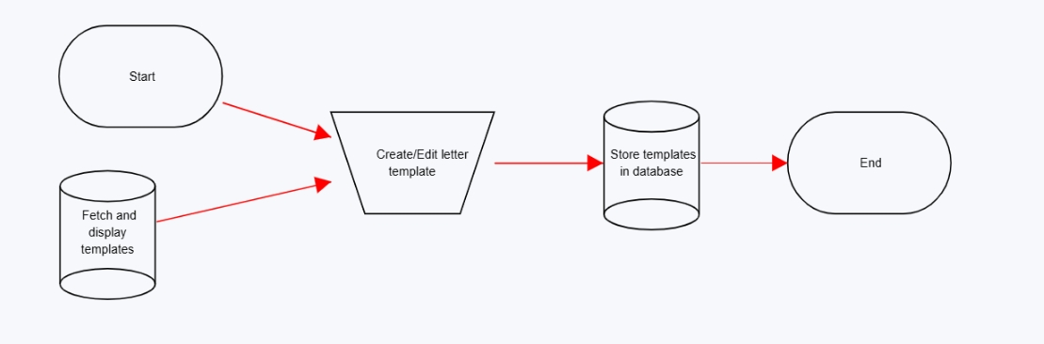

**7. Staff Management**

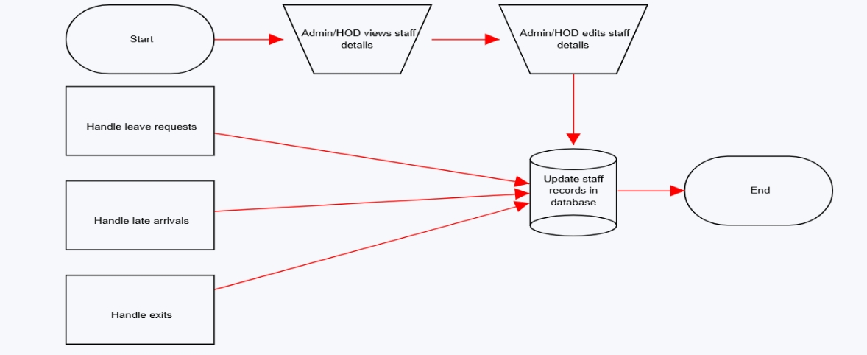

**8.Department Management  
  
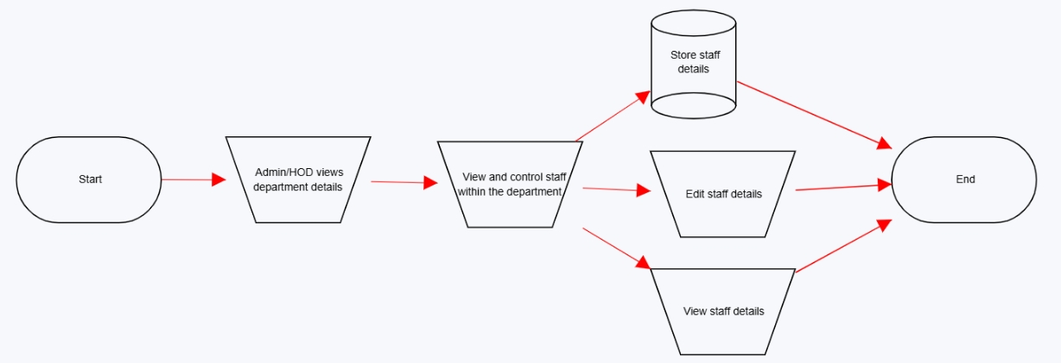**

1. **Admin Requests Review**

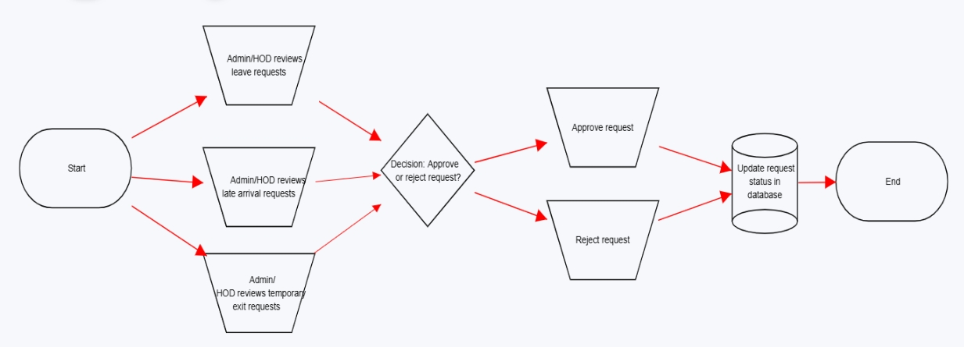

1. **Internal Mailing System**

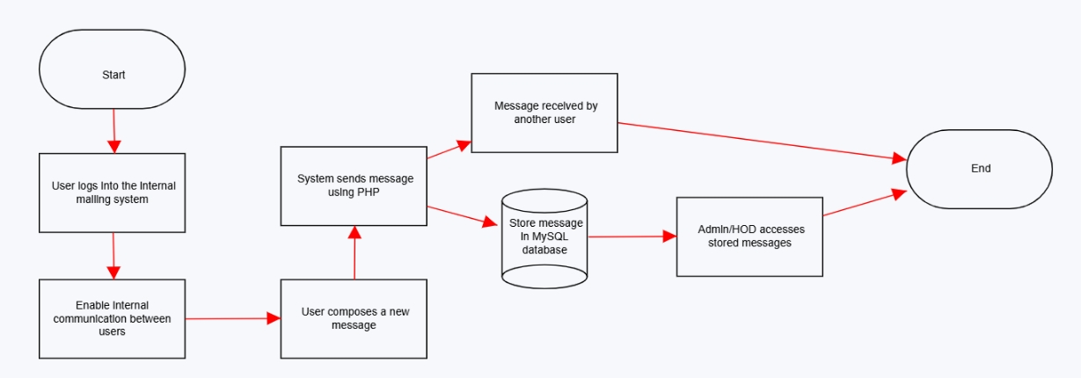

1. **Log Out**

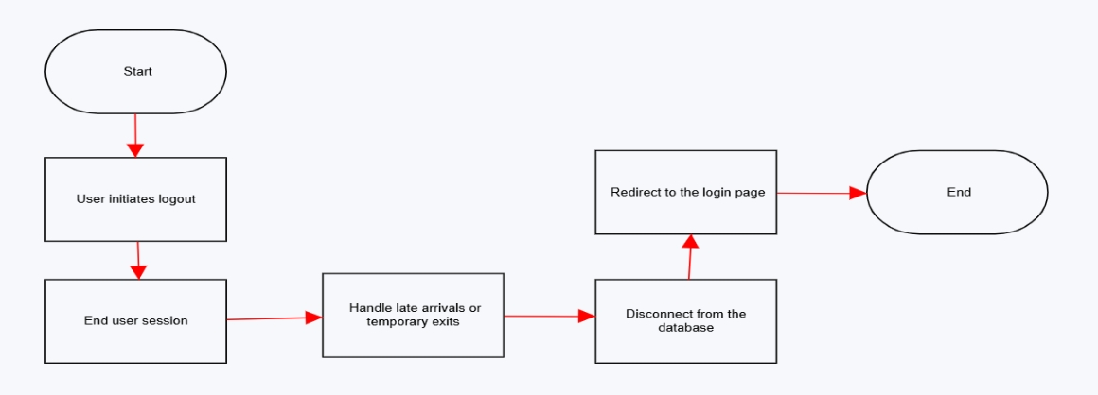

**3.7 ENTITY RELATIONAL DIAGRAM/ DATA FLOW DIAGRAM  
  
1. Applicant and the system  
  
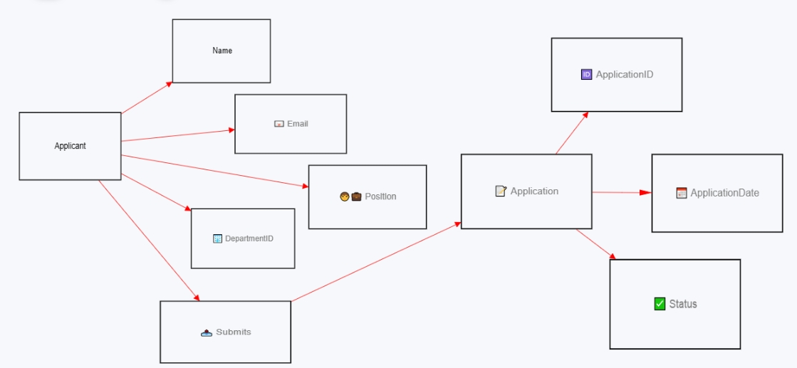**

1. **Admin, Hod, and Staff.**

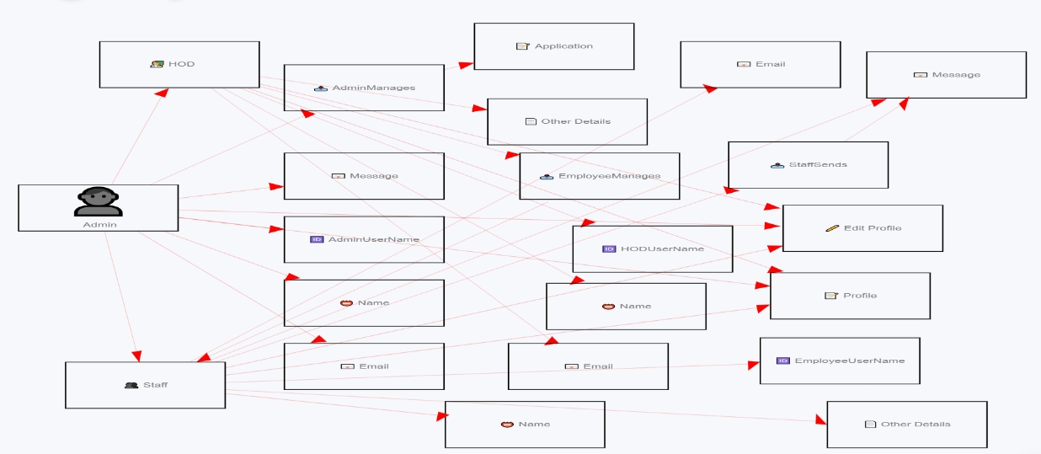

**CHAPTER FOUR: IMPLEMENTATION AND EVALUATION**

**4.1 PROGRAM DEVELOPMENT**

The development of Opibus involved several stages, starting with requirement gathering and analysis. This phase includes understanding the possible needs of an organization and defining the system's functionalities. The next step was designing the system architecture, which involved creating detailed diagrams such as Wire-Frames to visualize the User Interface(UI) structure. The development phase followed, where the system was built using PHP for server-side scripting, HTML and CSS for the front-end design, Bootstrap for responsive design, JavaScript for client-side scripting, and MySQL for database management. During this phase, codes were written to implement features such as resume submission, application review, interview scheduling, letter management, staff management, department management, and internal mailing. Testing a crucial part of development,was done to ensure that each module functions correctly and integrates seamlessly with others. This includes unit testing, integration testing, and user acceptance testing. Finally, the deployment phase involves setting up the system on a live server. Post-deployment, regular maintenance and updates are necessary to fix bugs, improve performance, and add new features based on user feedback.

**4.2 System requirement**

**4.2.1** **Software Requirements**

-Operating System: Windows, macOS, or Linux

- Web Server: Apache

- Database: MySQL

- Server-Side Scripting: PHP

- Client-Side Scripting: JavaScript

- Front-End Technologies: HTML, CSS, Bootstrap

- Development Tools: Visual Studio Code**.**

**4.2.2 Hardware Requirements**

- **Server:**

- Processor: Quad-core or higher

- RAM: 8GB or higher

- Storage: SSD with at least 100GB free space

- Network: High-speed internet connection

- **Client Machines:**

- Processor: Dual-core or higher

- RAM: 4GB or higher

- Storage: At least 20GB free space

- Display: 1024x768 resolution or higher

These requirements ensure that the system runs efficiently and can handle multiple users simultaneously without performance issues.

**4.3 SYSTEM INTERFACE**

**4.3.1 Input interface**

The input interface of the EMS is designed to be user-friendly and intuitive. It includes forms for various functions such as resume submission, leave requests, and interview scheduling. These forms are built using HTML and Bootstrap to ensure responsiveness and accessibility. JavaScript is used for client-side validation to provide immediate feedback to users and reduce server load. The input interface also includes drop-down menus, date pickers, and file upload fields to enhance user experience. For administrators and HR managers, the system provides dashboards with input fields for managing staff details, creating letter templates, and reviewing applications.

**4.3.2 Output interface**

The output interface is designed to present information clearly and concisely. It includes tables and lists to display data such as employee details, application statuses, and interview schedules. The system uses Bootstrap to create responsive layouts that adapt to different screen sizes. PHP and MySQL are used to fetch data from the database and display it dynamically on the web pages. The output interface also includes notification systems to alert users about important events such as interview schedules and leave approvals. For internal communication, the system provides a messaging interface where users can send and receive messages. This interface is designed to be similar to email clients, making it easy for users to navigate and use effectively.

**4.4 SYSTEM TESTING/ PERFORMANCE**

System testing for the Employee Management System (EMS), Opibus, involves several stages to ensure the system functions correctly and efficiently.

**- Unit testing:**  is the first step, where individual components like resume submission, application review, and interview scheduling are tested in isolation to verify their functionality.

-**Integration testing:** follows, ensuring that these components work together seamlessly.

-**System testing** is then conducted to validate the entire system's performance under various conditions, including normal and peak loads. This involves testing the system's response time, throughput, and resource utilization to ensure it can handle multiple users simultaneously without performance degradation

Overall, thorough testing ensures the EMS is reliable, efficient, and ready for deployment.

**4.5 SYSTEM TRAINING**

Effective system training is essential for the successful implementation of the EMS. Training was tailored to different user roles, including Admins, H O Ds, and Staffs.

****-**Training materials:** like user manuals, quick reference guides, and video tutorials provided to support ongoing learning.

**-Role-based training:** ensured that each use-case was understood and their specific responsibilities on how they’ll use the system effectively. For example, Admins training involved handlings on application review and interview scheduling, while HR managers should focus on letter template management and staff handling.

**4.6 CONVERSION TO THE PROPOSED SYSTEM**

Converting to the proposed EMS involves several steps to ensure a smooth transition from old mundane system,

**-Planning** the first step, where a detailed conversion plan was developed, outlining the timeline, resources, and tasks required.

**-Information implementation phase**, involved the use of existing data on similar, applications, and other relevant information for the development of the new system. This process included data cleansing to ensure accuracy and consistency.

**-User training** was essential during this phase to ensure all users are comfortable with the new system.

**- Testing** was conducted to verify that the data has been accurately migrated and that the new system functions correctly.

**- Go-live** the final step, where the new system is fully implemented, and the information of old system and other novel ideas are retired.

- **Post-implementation support** should be provided to address any issues that arise and to assist users with the transition. Regular **monitoring and evaluation** are necessary to ensure the system operates as expected and to identify any areas for improvement.

**4.7 SYSTEM DOCUMENTATION**

**4.7.1 User manual**

The user manual for the EMS should be comprehensive and user-friendly, providing detailed instructions on how to use the system. It should include sections on system navigation, key functionalities, and troubleshooting common issues. Each section should be illustrated with screenshots and step-by-step instructions. The manual should be organized by user roles, with specific instructions for admins, HR managers, HODs, and employees. For example, the admin section should cover application review, interview scheduling, and letter template management, while the employee section should focus on resume submission and leave requests. The manual should also include a glossary of terms and an index for easy reference.

**4.7.2 Operational manual**

The operational manual should provide detailed information on the system's technical aspects and maintenance procedures. It should include sections on system architecture, database management, backup and recovery procedures, and security protocols. The manual should also provide instructions for system administrators on how to perform regular maintenance tasks, such as updating software, monitoring system performance, and troubleshooting technical issues. Additionally, it should include guidelines for managing user accounts and permissions, ensuring data integrity, and maintaining system security. The operational manual should be regularly updated to reflect any changes or updates to the system.

**4.8 System maintenance**

System maintenance is crucial to ensure Opibus remains functional, secure, and up-to-date.

**- Regular maintenance tasks**  include software updates, security patches, and performance monitoring.

**- Preventive maintenance**  involves routine checks and optimizations to prevent potential issues, such as database indexing and server health checks.

**- Corrective maintenance** addresses any issues or bugs that arise, ensuring they are resolved promptly to minimize downtime.

**- Adaptive maintenance** involves updating the system to accommodate changes in the organization or external environment, such as new regulations or business processes.

- **Perfective maintenance** focuses on improving the system's performance and usability based on user feedback and technological advancements.

A **maintenance schedule** will be established, outlining regular tasks and their frequency. **Documentation** of all maintenance activities is will be made to track changes and ensure accountability. Additionally, regular **reviews and audits** of the system will be made to help identify areas for improvement and ensure the system continues to meet the organization's needs.

**CHAPTER FIVE: SUMMARY, RECOMMENDATIONS AND CONCLUSION**

**5.1 SUMMARY**

Opibus is designed to streamline and automate various HR processes within an organization. It allows prospective employees to submit resumes via a public landing page, which can then be reviewed by admins. Admins can accept or reject applications, schedule interviews, and manage interview outcomes. The system also provides functionalities for storing and managing letter templates for various HR purposes, such as hiring, firing, and notices. Additionally, it handles staff management, including leave requests, late arrivals, and temporary exits. Heads of Departments (HODs) can manage staff within their departments, while the system also supports internal communication through an integrated mailing system. Opibus is made to ensure efficient department management and allows for the review of admin requests.

**5.2 RECOMMENDATIONS**

**User Training**: Conduct comprehensive training sessions for all users, including admins, HR managers, HODs, and employees, to ensure they are proficient in using the system.

**Regular Updates**: Implement regular software updates to incorporate new features, fix bugs, and improve system performance.

**Data Security**: Enhance data security measures to protect sensitive employee information and ensure compliance with data protection regulations.

**User Feedback:** Establish a feedback mechanism to gather user input and continuously improve the system based on their needs and suggestions.

**Scalability**: Ensure the system is scalable to accommodate the growing needs of the organization and handle increased data volumes and user traffic.

**5.3 CONCLUSIONS**

This EMS provides a comprehensive solution for managing various HR processes within an organization. By automating tasks such as resume submission, application review, interview scheduling, and staff management, the system enhances efficiency and reduces administrative workload. The integrated mailing system facilitates seamless communication between users, while the ability to manage letter templates and department-specific staff ensures a well-organized HR function. The system’s capability to handle leave requests, late arrivals, and temporary exits further supports effective workforce management. Overall, tOpibus is a valuable tool for improving HR operations and supporting organizational growth.

**REFERENCES**

- https://www.academia.edu/

- [https://portal.bazeuniversity.edu.ng/](https://portal.bazeuniversity.edu.ng/%20https:/itsourcecode.com/%20https:/arkajainuniversity.ac.in/%20https:/peoplemanagingpeople.com/)

[- https://itsourcecode.com/](https://portal.bazeuniversity.edu.ng/%20https:/itsourcecode.com/%20https:/arkajainuniversity.ac.in/%20https:/peoplemanagingpeople.com/)

[- https://arkajainuniversity.ac.in/](https://portal.bazeuniversity.edu.ng/%20https:/itsourcecode.com/%20https:/arkajainuniversity.ac.in/%20https:/peoplemanagingpeople.com/)

[- https://peoplemanagingpeople.com/](https://portal.bazeuniversity.edu.ng/%20https:/itsourcecode.com/%20https:/arkajainuniversity.ac.in/%20https:/peoplemanagingpeople.com/)

- <https://go.jeda.ai/>

-h-ttps://moqups.com/

-https://www.geeksforgeeks.org

-https://copilot.microsoft.com/

-https://softwareconnect.com/

-https://www.mckinsey.com/

**APPENDICES**

**Appendix 1: Background of the Study**

Opibus is designed to streamline HR processes within organizations. It addresses the need for efficient management of employee data, application reviews, interview scheduling, and internal communication. The system leverages modern technologies to automate routine tasks, thereby enhancing productivity and reducing administrative burdens.

**Appendix 2: Statement of the Problem**

Many organizations struggle with managing employee data and HR processes efficiently. Traditional methods are often time-consuming, error-prone, and lack integration. This project aims to develop an EMS that addresses these challenges by providing a comprehensive, automated solution for managing employee-related tasks.

**Appendix 3: Aim and Objectives**

The aim of this project is to develop an EMS that automates and streamlines HR processes. Objectives include:

-Enabling resume submission and application review.

-Facilitating interview scheduling and decision-making.

-Providing tools for managing staff details and HR letters.

-Implementing an internal mailing system for seamless communication.

-Ensuring data security and user-friendly interfaces.

**Appendix 4: Significance of the Study**

Opibus will significantly improve HR operations by automating routine tasks, reducing errors, and enhancing data security. It will enable HR professionals to focus on strategic initiatives, thereby contributing to overall organizational efficiency and productivity.

**Appendix 5: Scope and Delimitation of the Study**

The study focuses on developing an EMS for small to medium-sized organizations. It includes functionalities such as resume submission, application review, interview scheduling, staff management, and internal communication. The study does not cover large-scale enterprise solutions or integration with external HR systems.

**Appendix 6: Definition of Terms**

-EMS: Employee Management System.

-HR: Human Resources.

-Admin: Administrator responsible for managing the system.

-HOD: Head of Department.

-Resume: A document submitted by job applicants detailing their qualifications and experience.

-Interview: A formal meeting to assess the suitability of a job applicant.

**Appendix 7: Introduction**

The EMS project aims to develop a comprehensive system for managing HR processes within organizations. It addresses the inefficiencies of traditional methods by providing an automated solution that enhances productivity and data security.

**Appendix 8: Theory**

The theoretical foundation of Opibus is based on database management systems (DBMS) and web technologies. The system uses PHP, MySQL, HTML, CSS, Bootstrap, and JavaScript to create a robust and user-friendly platform for managing employee data and HR processes.

**Appendix 9: Review of the Related Work**

Existing EMS solutions like BambooHR and Other free open source EMS have set industry standards by offering comprehensive HR functionalities. These systems emphasize user-friendly interfaces and robust data security measures.

**Appendix 10: Analysis of the Existing System**

Current EMS solutions offer comprehensive HR functionalities but often face challenges with integration, and user adoption. They require substantial customization to meet specific organizational needs, which can be time-consuming.

**Appendix 11: Weakness of the Existing System**

Existing EMS solutions have notable weaknesses, including high implementation and maintenance costs, integration challenges, data security concerns, and complex interfaces that hinder user adoption.

**Appendix 12: Data Collection Techniques**

Data for Opibus was collected through online research, reviewing documentation and tutorials, analyzing competitor systems, reading academic papers and case studies.

**Appendix 13: Analysis of the Proposed System**

The proposed EMS aims to address the shortcomings of existing solutions by offering a flexible, and user-friendly platform. It integrates resume submission, interview scheduling, and internal communications into a single cohesive system, ensuring user adaptability.

**Appendix 14: System Algorithm**

The system algorithm includes initializing the system, user authentication, resume submission, application review, interview scheduling, post-interview decision, HR letter management, staff management, department management, admin requests review, internal mailing system, and logout.

**Appendix 15: System Flowchart**

The system flowchart visually represents the key processes within the EMS, including initializing the system, user authentication, resume submission, application review, interview scheduling, post-interview decision, HR letter management, staff management, department management, admin requests review, internal mailing system, and logout.

**Appendix 16: Entity Relational Diagram / Data Flow Diagram**

The Entity Relational Diagram (ERD) for the Employee Management System (EMS) illustrates the relationships between entities such as Employees, Applications, Interviews, Departments, and Letters. Each entity is connected through primary and foreign keys, ensuring data integrity and efficient data retrieval. The Data Flow Diagram (DFD) depicts the flow of information within the system, highlighting processes like resume submission, application review, interview scheduling, and internal communication.

**Appendix 17: Program Development**

The development of Opibus involves several stages, including requirement gathering, system design, coding, testing, and deployment. The system is built using PHP for server-side scripting, HTML and CSS for front-end design, Bootstrap for responsiveness, JavaScript for client-side scripting, and MySQL for database management. The development process includes creating modules for resume submission, application review, interview scheduling, HR letter management, staff management, and internal mailing.

**Appendix 18: System Requirement**

**Software Requirements**:

- Operating System: Windows, macOS, or Linux

- Web Server: Apache

- Database: MySQL

- Server-Side Scripting: PHP

- Client-Side Scripting: JavaScript

- Front-End Technologies: HTML, CSS, Bootstrap

- Development Tools: IDEs like Visual Studio Code or PhpStorm, version control systems like Git

**Hardware Requirements:**

1. Server:

- Processor: Quad-core or higher

- RAM: 8GB or higher

- Storage: SSD with at least 100GB free space

- Network: High-speed internet connection

1. Client Machines:

-Processor: Dual-core or higher

- RAM: 4GB or higher

- Storage: At least 20GB free space

- -Display: 1024x768 resolution or higher.

**Appendix 19: System Interfac**e

**Input Interface**: The input interface includes forms for resume submission, leave requests, and interview scheduling. These forms are built using HTML and Bootstrap for responsiveness and accessibility. JavaScript is used for client-side validation to provide immediate feedback to users.

**Output Interface**: The output interface includes tables and lists to display data such as employee details, application statuses, and interview schedules. Bootstrap is used to create responsive layouts, and PHP and MySQL are used to fetch and display data dynamically.

**Appendix 20: System Testing/Performance**

System testing involves unit testing, integration testing, and system testing. Performance testing includes load testing and stress testing to ensure the system can handle multiple users simultaneously without performance degradation.

**Appendix 21: System Training**

System training includes initial training sessions, interactive exercises, and supporting materials like user manuals and video tutorials. Training is tailored to different user roles, including admins, HR managers, HODs, and employees.

**Appendix 22: Conversion to the Proposed System**

The conversion process involves planning, data migration, parallel running, user training, testing, and go-live. Data migration includes transferring existing employee data and applications to the new system. Parallel running allows users to become familiar with the new system while ensuring continuity of operations. Post-implementation support is provided to address any issues that arise.

**Appendix 23: System Documentation**

**User Manual**: The user manual provides detailed instructions on how to use the system, including system navigation, key functionalities, and troubleshooting common issues. It is organized by user roles, with specific instructions for admins, HR managers, HODs, and employees.

**Operational Manual:** The operational manual provides detailed information on the system’s technical aspects and maintenance procedures. It includes sections on system architecture, database management, backup and recovery procedures, and security protocols. It also provides instructions for system administrators on performing regular maintenance tasks.

**Appendix 24: System Maintenance**

System maintenance includes regular software updates, security patches, and performance monitoring. Preventive maintenance involves routine checks and optimizations to prevent potential issues. Corrective maintenance addresses any issues or bugs that arise. Adaptive maintenance involves updating the system to accommodate changes in the organization or external environment. Perfective maintenance focuses on improving the system’s performance and usability based on user feedback and technological advancements. Regular reviews and audits are conducted to ensure the system continues to meet the organization’s needs.